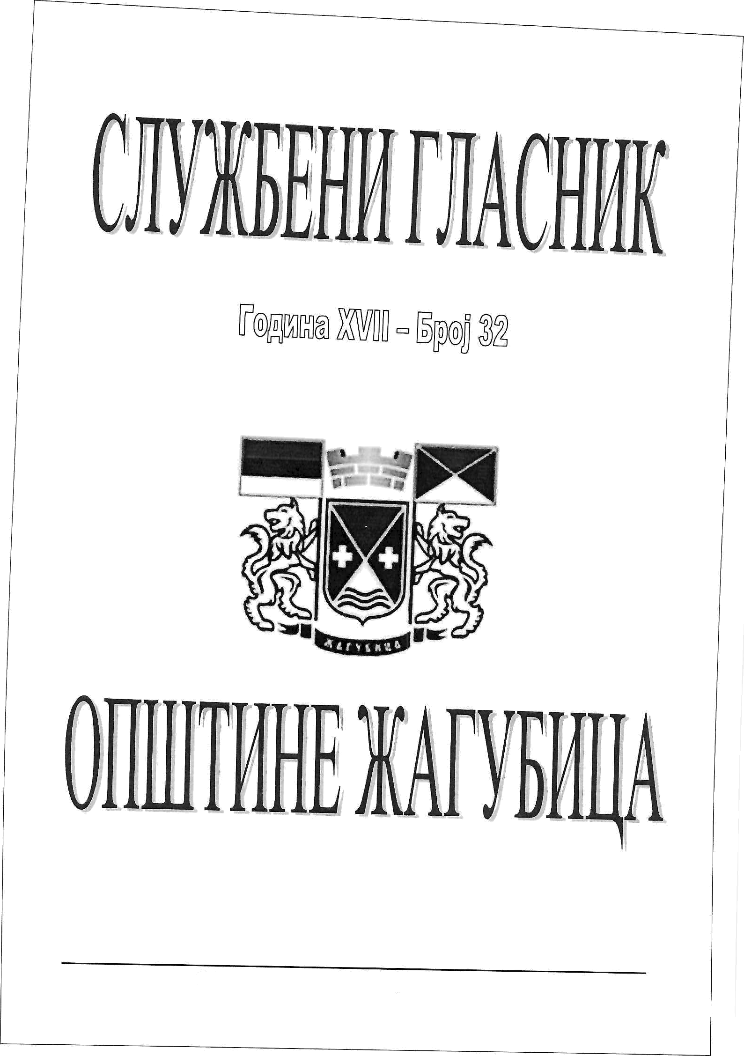

### Aary6nua, 08. cenzeu6ap 2022. roqiiiie

MW.Za ubica.or

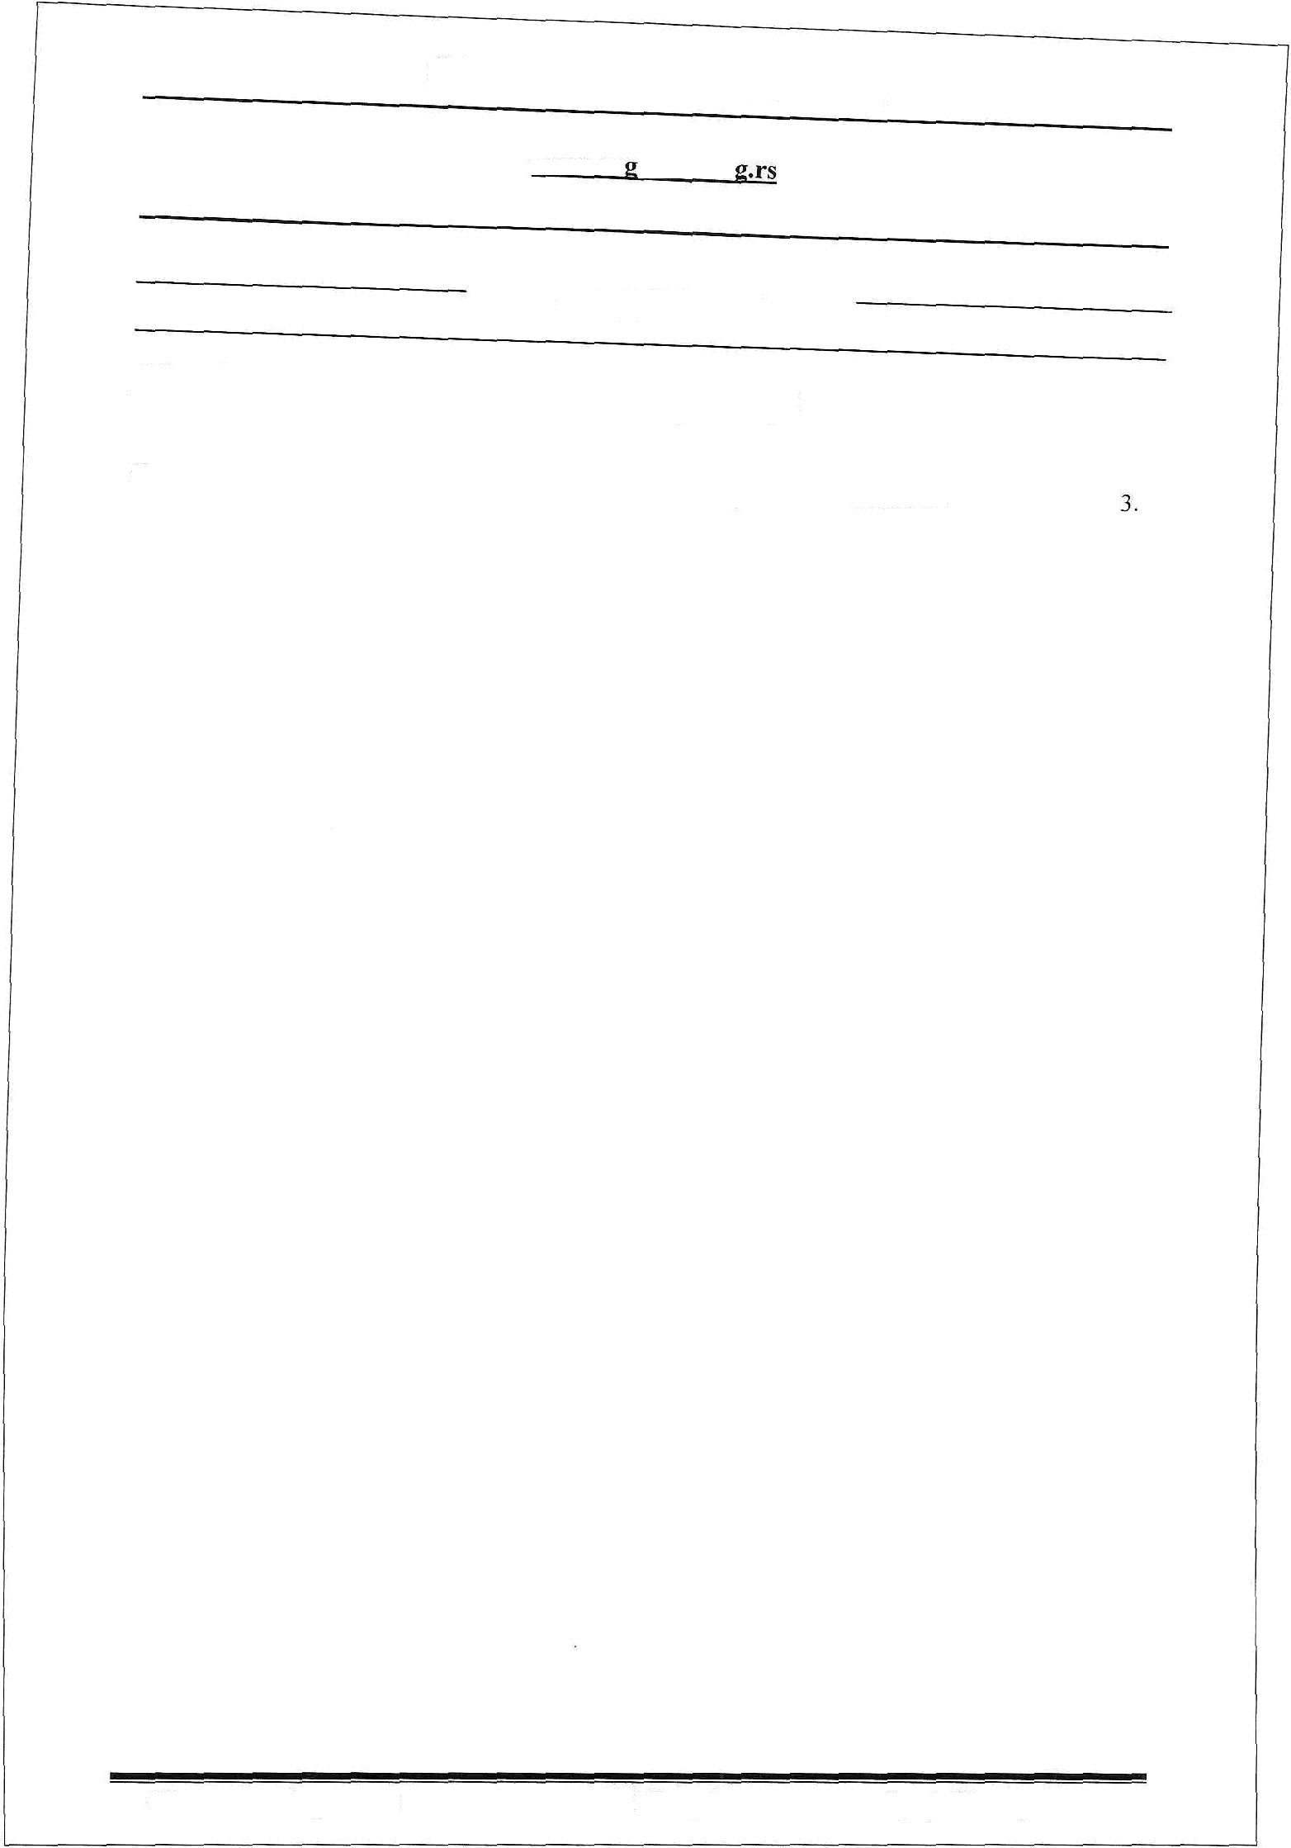

### C A @ P W A J

*Hpebceba uu onmmuae Ma duqa*

Ornac sa naaaioe y saxyri ri ma xopmuheise nou onp B p e niior seMaiiuiTa.

###### 08. cenieu6ap 2022 Mary6Pt\a fipoj 32 cipaHa 2

8 OOHOBJ Ghana 64. cTaa 3. 3axoHa 0 noaonpn«pequox 3evnuiirry („Coyv6eiiii rnacuiiK PC“, 6p. 62/06, 65/08 — 9 , 3flK00, 41/09, 112/15, 80/1'79 95/18— *yep.* aaiior), Dpaau»iirixa *o* ycnoaiimar noerynxy



6p.16/2017, 111/2017, 18/2019, 45/2019, 3/2020, 25/2020, 133/2020 e 63/2021) ii x a a 29.12.2008.

Opnyxe o oqpeljnBaisy xa,gaeH£HOr oprana za cnpoBoJerse riociynxs naBaisa y oaxyn oononpoBpepHor

aemzniTa y pp›EaBxoj cBojuoii («Cnyw6enz zHCT oriiuzone WAFYfiHL{A» 6poj *Oniuyriiie* Wary6iitta 6po), Dpepcenrinx onurrniie lKAFYfiHJjA je mana roqsrte, poHeo

O **PACITHC mr** iwHor ormcA 3A pre y s3

x **HA KOPI4IIfA8H›z**

Y OIBliHDDI

rr *pacmicyje*

o r n A c

3A ,A,ABAf£B Y 3AKYrI u Hn **KOPHIIHIE** o nouonrinrR or **3emHIIITA Y ,QPXtABHOJ**

CBOJHIDI v OIBilTHHH

I

- IIpe/ cezjasaor aa,/pcez sa -

1. Pacrincyje ce ornac sa pasaue y saxyn rt ma *i‹op*ir*uihe*is*e* nouonpiiBpepnor se zurra y ppwaanoj caojrinri no ycnosiiMa **qpyror gpyra** y onurmno HAFYbllijA y cnepetiw xazacyapcxnri onnrnieava:

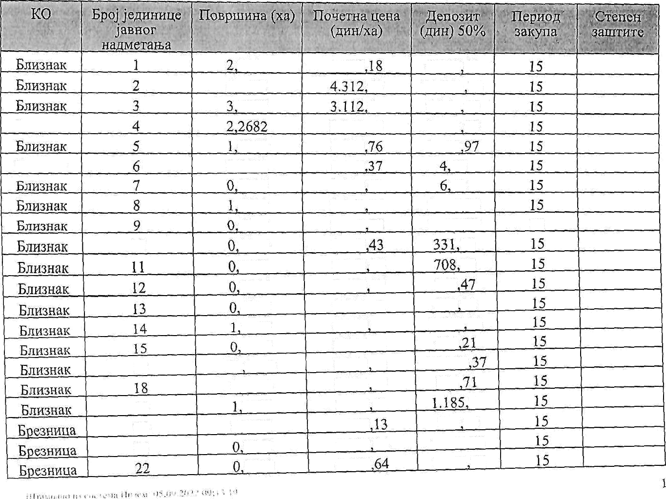

19

20

21

|  |  |  |  |  |
| --- | --- | --- | --- | --- |
|  | 9145 | 2.920 | 4.255 43 |  |
| 6,9161 | 60 | 14.91319 |
| 4457 | 42 | 5.36224 |
|  | 3.319.86 | 3.765 05 |
| 8850 | 1.926 | 1.815 |
| 0,0079 | 1. t49 | 54 |
| 0117 | 1.149 57 | 72 |
| 4627 | 2.365 44 | 1.729.96 |
| 6127 | 5.744 95 | 1.759,97 | 15 |
| 10 | 2800 | 2.365 | 16 |  |
|  | 5989 | 2.365 44 | 33 |  |
|  | 0856 | 3.492 17 | 149 |  |
|  | 4030 | 2.730,92 | 550 28 |  |
|  | 0397 | 4.366 69 | 2.270 03 |  |
|  | 4959 | 2.214,98 | 549 |  |
| 17 | 21 2750 | 2.365 44 | 25.t62 |  |
|  | 0,6234 | 2.584 87 | 805 |  |

|  |  |  |
| --- | --- | --- |
| 2997 | 1.824 61 72 | |
| 0.0781 | 3.737 | 145 93 |
| 3241 | 7.097 04 | 1 , 150.08 |
| gz59 | 4.537 | 1.873 82 |

Bvi‹

### B

B

171

24 0,4005

0925

2

0 6141

1518

29 5997

0 5164

0 3000

5785

2,6844

34 1969

4920

36 2000

6257

38 9,0432

39 8955

0660

97

###### 803 11

7.097 04 744

9.124

7,173 30

9.124

47

J92 01

4.730 88

4.730 89

2!

594 26

6.1 I S 86

g

90

04

2.735

14

1.368

2.267 10 4.821 19 465 76 1.163,80

7 925 95

16.2§1

2.739

1s

15

15

15

t 5 j5 15

5

15

15

15

15

15

15

‹

41

### B

:0B 47

#### 48

B

6x 50

52

0 2792

1564

5635

0

4145

0215

0479

0928

8932

0620

8079

079!

6850

6,4737

3608

2, 72

8.110,4

9.124

47

5.744,89

9.124

2.47

06

2.865 23

2.484,56

2.419.97

401 00 15

3,407,90 i s

15

4.546 6 t5

9 is

4.34001 l5

15

423 15

zgz g 5

3.62712 is

1.157,41 ls

96 15

987,' 15

p2 j5

,

Hary6zua Mary6iiua

lary6z a Hary6iiua Mary6zqa MarY6xua 2£arv6xua lary6iiUa Aary6zua Vary6»qa 7Itary6xua 7Kary6zpa 7Kary6oua Harv6xiia

56 0,6216

57 0,0385

§8 1 1367

59 0 2173

60 0,2493

61 2,3036

62 0,4983

63 0,2272

64 4,7542

65 8.7943

66 2,5291

*6J* 0.0604

68 0,1794

69 0,0324

70 0.8489



L824,61 1.436.36

2.365,44

3.492,18

1.436,26

1,436,26

1.436,26

1.436,27

1.436,26

1.436,26

1.436,26

1,436.26

1,436,23

1.436.11

1.436.26

567,09 1 5

9 7 65 5

1.344 40 i s

379.43 J 5

179,03 15

1.654,2b 15

357,84 lJ

163,16 15

3.414,13 15

6.315.44 15

1.816,22 15

43.37 15

128,83 15

23.27 15

609,62 15

3.3 qq

3. ooua

3. 3oria

3. 3oiia

3. soiia

3. 3OHH

3. aorta

3. fora

3. fora

3. 3oiia

3. ooHa

1. bona

2

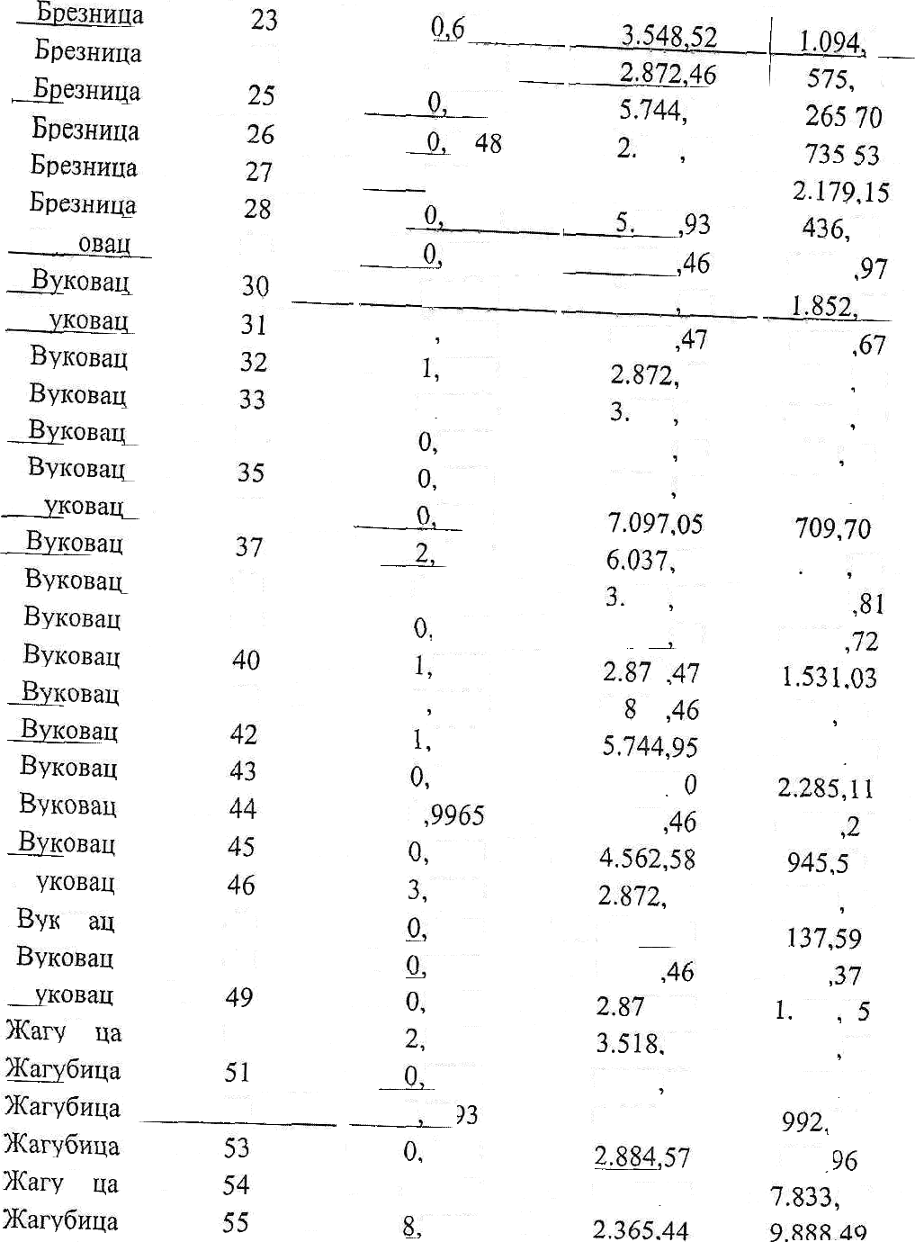



7Kary6oya

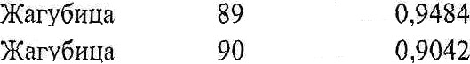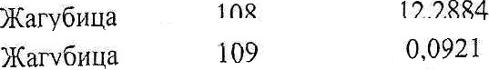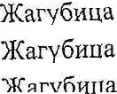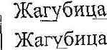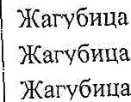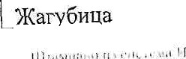

)Katy6zua Msq6xua Aary6flMñ Kary6niia Mary6zua Varr6nita 8 **@1I9H**

7Larr6aua Aarr6iiua I£ary6nua 7Kary6zqa Hary6xqa Aary6Hua 7Karv6zua Aary6xqa Aary6xpa Yary6nqa

Marv6iiQñ Mary6xua Marv6iiua arv5z ia lary6oiia Harv6zra Harv6zua

,mfiuiia Warv6rua **KarvCuiia** Warv6uria w»rv6oii Hary6zpa

6«rin

2£nrvfixiia *Narxi€oiia* Vary6xya

71

72

#### 73

74

75

76

77

78

79

80

81

82

83

84

85

86

87

88

91

92

93

94

95

96

97

95

99

ln0 101

Joy

l *a 104

105

lDfi

*7

1i0 111

112

##### in

114

lls 116

117

118

0. i 066

03647

#### 0,3494

0.0623

0.4313

2.2140

0.4428

0,0423

2.3761

0.3538

0,1560

05100

191964

0,1502

0,S518

0,9299

1q0257

0q0799

0.2357

2.8589

0.4409

0,0625

0.6780

0,3412

0,1906

0 3301

0.lJ84

0.6778

0.0036

0.0048

0 8834

0.0350

0.1391

1 J448

04748

1.0389

0,1511

0,0625

##### 0,2515

0,4488

0,j130

0.4981

0,1500

0,5284

1.436.21

2.049,96

1.824,61

2.049,92

2.583.86

2.365.44

4.730.89

1.149.17

8.110,40

10.250.51

5.632,j1

9.12445

5 744 95

5,632.16

5.744.94

3.548,52

4.88403

8.110J9

7.097,04

9.618,86

11 264.57

8.243,68

l 1.264,55

7.578.72

11.150,29

5.463.51

9.12445

10.250,50

4.56258

4.562p58

2.252,78

2.364.58

4.730,89

4.730.86

4.730,91

2.625.55

2.365.44

2.415,99

s a92 I s 3,492,18

5 fi3730

11.264,64

4.562,58

9.12447

4.562,59

a s6u 58

9.124,47

a s6o s9

76.55

373.81

318.76

63,86

557,21

2.618,54

1.047.42

24,31

9.635p56

1.813,31

439p32

2 326,j4

3.43663

422,98

1.010.54

1.649 88

2.504,77

32401

3.365,42

4.348,69

1 327,j3

I1.783,93

2.483,27

236,84

3.779,95

932,07

869,56

1.691,85

270,10

1.546,26

4,05

5,68

2.089,63

82,79

329,03

1.765,42

561 J6

14.844,34

160.81

1.814,01

425.52

352.02

573.74

2.047,53

714 04

1.136,31

684.33

1.205,43

15

I fi 15

15

15

15

15

15

15

15

15

15

15

15

15

15

15

15

15

15

15

15

15

15

15

15

15

15

*I S*

15

15

15

15

15

15

15

15

15

15

15

15

15

15

!8

15

15

15

15

3

Harr6nua Aary6iiqa Hary6iiqa Hary6ztia ar 6aita lary6zua Kary6iiua KaryfiHga Mary6auo Aary6npa Kary6zpa Yary6zua Aarv6rrua Mary6rpa Mary6iiqa Aary6zua Mary6itqa Aary6nua Yary6xuñ Marv6aua Harv6xqa AarY6nua Mary6xua Aary6zua Aom6oiia 4Rarv6uria 2t»rvfi«i'a **HarvGoua** W«rvfioHn Warv6ulia V€arv6uiia lJusanxiia Usnaniiiia Dauaniiria

HsBa x a

lloza iiua

119

120

121

122

123

124

125

126

127

128

129

130

131

132

133

134

135

136

137

138

139

140

141

142

143

144

145

146

147

145

149

150

151

152

161

162

4,0672

0,2584

0,6550

### 07350

0,1150

0,1295

4.8005

1,0162

2,4685

0,9999

0,8000

0 3427

0.0295

0,1149

0,8913

0,6626

0,7166

2,0426

0,5256

0.7905

0,1585

0.2586

0.0714

1,4399

0.0071

0.3100

0.2106

3.8538

0.7fi2S

0.0612

0,1324

2.1667

0p8493

0.2627

0.4540

1.1 627

0.fi396

9.4878

0 7043

0,5415

0,3376

0,0318

0,3 t57

1,1171

0,3167

0,6358

2.365.44

3.492.18

1.436.26

1 436,26

1.436,j6

1 436.29

1.436.26

1.436,25

1.436p26

.436g25 1.436,26

10.250.51

5.125.08

8.110,36

2.049g95

?.390,46

2.365.43

2.365.44

2.365,45

4.562,58

11.264.54

5.632.29

11.264,57

2.479,71

3.491.55

7.966.19

1.149.29

1.436,26

1.43fi 26

1.436,2g

1.436.25

2.631,39

10.159,23

3.930,72

1.436,26 l.436,26 1.436,26

o and 44

1 zv4 6i

4.730,90

3.548,52

2.049,97

9.124 63 2.365,44 i sha u1 2.365,42

^ 7 36

4.810.36 Js

451.19 15

470,37 15

168.76 15

82,58 15

93.00 15

3.447.38 15

729p76 15

1.772,70 15

718,06 15

574,50 15

1.756,42 15

75,60 15

465 94 15

913,56 15

791,96 15

847.54 15

2.415.82 15

62l@4 15

1.803,36 15

892.72 15

728,25 15

402,14 15

1.785 26 15

12,40 15

1.234,76 15

121,02 15

2.767,52 15

561.94 15

43,9d l3

95 08 15

2.850,j2 15

4.314,12 IS

516,30 15

326,03 15

834.97 15

459,31 15

576.93 15

642.54 15

1.280,89 15

598 99 15

158,97 15

145,08 15

| 373,38 15

| 1.019.14 15

374,57 15

1.498,70 15

3. soHa

3. fora

3. Moira

3. soHa

3. 3oitd

3. soxa

3. soxa

3. Moira

3. Moira

3. fora

3. noma

3. soda

3. Moira

3. fora

3. soiia 3. °°"^

2,8410

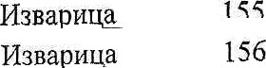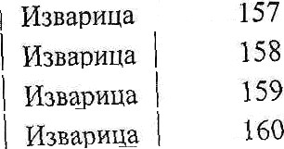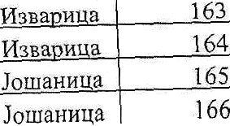

7.672.87 10,899,31 15

Jouiaiinua

Joma8opa Jomauxpa Joiuazxpa

Joiiiaa«ua Joiiiaonaa Jomauzua Jomaax a Jomaiinua Jouiaaxua

JoI1Iaii»9a Joiiiaiiri9a Jouiaxxua

Joiiiaxzua Joiiiaoiiua

Jouiazriua

JoiiiaoHua Jouiartxua Joiiiaiiiiua

Iniuaariia Iniii»ouii«

Knenorsvri

KpenonzH Kpeuoiua

Koenon.no

KpenoaPtH

Krienon.«u

hpeno nu

167

168

169

170

171

172

173

174

175

176

177

178

179

180

181

182

184

185

187

189

190

191

192

t93

200

°*

204

>>

208

314

1,5424

1,4769

0,9312

0.3764

0,5241

1,4678

0.2533

0.3009

0.0786

0,2727

0,1188

0,3223

0,0544

0 2215

0,j 411

0.0667

0 1151

0,0340

0.3368

1,2103

0.6601

0.2300

0.1665

0.1934

0.3967

0.0800

p.3g79 0.1283 1.4GAS

1 3vd

R99f

1.0029

0.1500

0.4300 0.0400 1,0000 1,2039 0 6300 0,2643 0,1108

0,0884

0.4692

0,1559

0,7728

0,2156

2,6121

0,1542

0.244B

5.952.17

7.710,02

5.731,93

4.730,90

2.872.47

2.872,47

3.492,18

5.744.97

1.867.94

2,872 46

7.097,05

7.097,05

7.097,06

7.097.02

7.097,02

7.097.00

7.097,05

5.745,00

5.579.69

5,265.53

7.729,48

8.IU.39

8.110.39

7.097,05

3.339 98

7.097.00

8.110.39 2.786.98 3 063.37 4.934.88 4.7B3,45 4.419,90 8.110,40 5.744,95 9.124,50 4.730.89 2.365,44 4.730.59 7.097,05 5.770,22 a nss 5d

4 7

4.730,92

i ri o en en 9.124,44

v a6s 44

z i i 0 38

7.097,06

4.590.31 15

5.693.47 15

2.668.79 15

890,35 15

752.73 15

2.108,11 15

442,28 15

564.33 15

73.41 15

391,66 15

421,56 15

1.143,69 15

193,04 15

786.00 15

500,70 l5

236,69 15

408,43 15

97,66 15

939,62 15

3.186.44 15

2.551.11 15

932.70 15

675,19 15

656,25 15

662,48 15

283,88 15

1.573,01 15

178,78 15

3.717.78 15

2.793.14 15

4.528,97 15

2,2 I 6,36 1 J

608,28 15

1.235,16 15

182,49 15

2,365,45 15

1.423,88 15

1.490,23 15

937.87 15

319.67 15

179.26 15

7 140.60 15

368,77 15

3.960.79 ! 8

983.62 15

3.089,? 8

625.31 15

•i ng 15

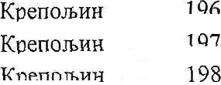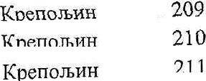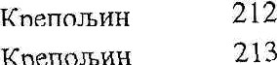





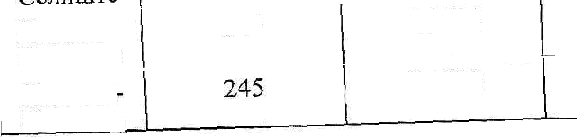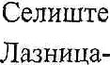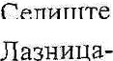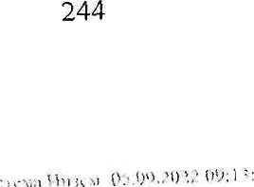

Kpenoazo Kpyna)a KpYna;a Knvnaia Kpyiiaa Kqynaa Kpynaja Kpynata

Jld3azqa-

CennuiTe

CenniiiTe

CeuHurre

Jlmiinqa- Cenniirre

JlMHnua-

Cenzurre Jlmiiaita-

Cenlliirre

**LaZHM8d-**

Cenauiie

Jlmiiuqa-

Uen›iiirre

fld3Hxua-

Saa«itia-

CeniiniTe

CeniiiiiTe CenuiuTe

216

217

218

219

220

221

222

223

224

225

226

227

228

229

230

23|

232

233

234

235

236

237

238

239

240

241

242

243

0,2299

2,2037

0,1716

0.4557

1,4758

0,4677

0,5197

0.0200

0.7630

0,6J92

1,6350

9,4803

3,7222

0,4310

0,7173

1,9038

0,1550

0,5747

0,1874

1,0235

0,9860

##### 22067

0,4295

0,6667

0,3751

0,s015

0,4101

0,5223

4,5494

0,lb08

5.744.93

2.365,44

4.099,18

1.436.25

1.436,26

2.36545

3.492,19

5.745.00

2.759.03

2.613,87

2.872,47

2.688,09

3.000,63

6.240,09

6.857,52

4.471,34

4.369,40

6.692,84

5.025,56

3.463,07

2.728,19

4.062,72

2.365,44

2.872,48

8.110,39

7.097,04

9.029,39

5.125,26

§.744,96 2.365,44

4.730,56

660.38 1 S

2.606.36 15

351971 15

327,25 15

1.059.81 15

553 16 15

907.44 15

57.45 15

1.052,57 15

861,53 15

2.348,24 15

12.741,96 15

5.584,47 15

1.344,74 15

2.459,45 15

2.432,63 15

4.159,23 15

673,69 15

1.444,09 15

324,49 15

1.396,15 15

2.002,92 15

2.609,91 15

616,86 15

2.703,60

1.331,05 15

2.264,12 15

1.050,93 15

1.500,29 t 5

5.380,67 15

427,67 15

3. Moira

1. bona

Jlmiiiiqa- Cesiiiute

|  |  |  |  |  |  |
| --- | --- | --- | --- | --- | --- |
| 246 | 0,2455 | 1.824,60 | 225,97 |  | 15 |
| 247 | 0,9181 | 2.365,44 | 1.085,86 |  | 15 |
| 248 | 0,2283 | 4.730,88 | 540,03 |  | 15 |
| 249 | 2,3560 | 2.353,63 | 2.772,58 |  | 15 |
| 250 | 1,9346 | 2.279,23 | 2.204,69 |  | 15 |
| 251 | 0,4406 | 2.365,43 | 521,11 |  | J3 |
| 252 | 0,6069 | 2.365,43 | 717,79 |  | 15 |
| 253 | 2,7051 | 1.824,61 | 2.467,88 |  | IS |
| 254 | 2,7652 | l.839,57 | 2.543,38 |  | 13 |
| 255 | ,5427 | 2.365,44 | 1.824,58 |  | 15 |
| 256 | 0,8387 | 2 365,43 | 991,95 |  | 15 |
| 257 | 0,2369 | 2.365,43 | 280,19 |  | 15 |
| 258 | 0,2237 | 3.492,18 | 390,60 |  |  |
| 259 | 0,0069 | 10 250,72 | 35,36 |  | 15 |
| 260 | 0,0174 | 8.110,34 | 70,56 |  | l5 |
| 261 | 0,5218 | 8.110,41 | 2.116,00 |  | 15 |
| 262 | 0,2036 | 7.097,05 | 722,48 |  | 15 |
| 263 | 0,3792 | 4.562,58 | 865,07 |  | 15 |

Ceneiuye Ceniimze Cennt Tfl

Jlaaiioqa-

Cesiif£rPe

Jlmuxua-

CenrHnTe

Jlasiirpa- Censure

Jlaaiixua-

CeuiiiuTe



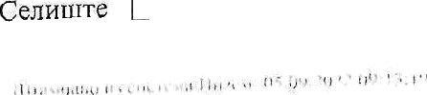

r ,.,.,









6.596,45

2.365,44

|  |  |  |  |
| --- | --- | --- | --- |
| Jlmiiiipa- Cexxuiie | 266 |  | 0,4000 |
|  | 267 |  | 2,4152 |
| CenzuiTe |  |  |  |
|  | 268 |  | 4,2299 |
|  | 269 |  | 1,6114 |
|  |  |  |  |
|  | 270 |  | 0,5783 |
|  | 271 |  |  |
|  |  |  |  |
|  | 272 |  | 0,5735 |

2.558,92

2,592,20



3.492,18

2.187,82

1.824,60

15

15

|  |  |  |  |  |
| --- | --- | --- | --- | --- |
| fla3Hfi4R- | 264 | 0,2557 | 4.055,53 | 518,50 |
|  | 265 | 0,0062 | 8.109,68 | 25,14 |

1.279,29 t3

2.856,51 15

5.411,99 15

2.088,54 t5

I.009,76 15

1.342,01 15

523,21 15

CflJlHuiTe

# flaaxpa-

#### CmamTe

Jlasxiiua-

Cenrtiire

CeniiuiTe

Jlaaiixqa- Cenaurre

JIazeHUh-

Cenmirre Ceniiiiire CenamTe

**fla3Hzua** CeazmTe JIa3iiiiita-

CeruuiTe

JIWH0U6-

Ceniinrre

###### Ce curre

flauxqa- ceso

273

# 274



275

276

277

278

279

280

281

282

283

284

285

286

287

288

289

290

291

292

293

294

295

296

297

298

299

0,0652

0,2433

2,0128

0,8736

0,1219

0,2227

0,2000

0,8867

0,2279

0,0367

0,1518

0,3336

0,0965

0,1018

0,6484

0,1779

0,3281

0,6487

0,0533

0,2537

0,2527

2,2532

0,1001

0,0099

0,1797

0,6162

5,8386

7.516,72

4.055,57

3.810,12

8.110,41

8.110,42

7.097,04

4.055,55

7.122,41

I 0.250,50

10.250,41

5.969,24

4.562,59

9.124,46

5.744,99

2 872,47

7 097,02

5 929,81

4.055,56

4.055,53

4 055,54

3.492,16

3.313,95

2 365,43

9.124,24

1.824,60

3.492,18

1.595,48

245,04 15

493,36 15

3.834,51 15

3.J42,62 15

494,33 15

790,26 15

405,56 15

3.157,72 15

1.168,04 15

188,10 15

453,06 l5

761,04 15

440,26 15

292,42 15

931,25 15

631,28 15

972,79 15

1.315,42 15

108,08 15

514,45 15

441,24 15

3.733,50 15

118,39 15

45,17 15

163,94 15

1.075,94 15

4.657,70 15





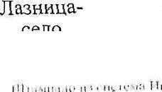

flLHHpa-

### cezo

ceno

Jlazxzqa- ceno

Jlmznua- ceno

G Pf 0 CSSO GGfIO

JIasxHpa-

cezo

**GPIO**

JIdSaHqa-

cezo

ceno

JIa3xoqa-

ceno

Jlaoiizua- ceno

JlasHHqa-

Jlmziiua-

Jlmxutta- ceno

Jlmnuua- ceno

300

301

302

303

304

305

306

307

308

309

310

311

512

313

314

315

316

317

318

319

320

321

322

323

324

325

4,0183

0,0630

2,2703

6,3813

5,8595

3,6624

0,2049

2,0029

0,0620

0,0036

0,0580

0,3411

#### 03039

0,5879

0,2498

0,4695

0,6762

0,3101

6,3050

0,2234

0,3948

2,6367

0,9678

1,3228

0,0616

0,3918

3,703,43

1.824,60

3.276,33

2.569,47

2,626,70

2.833,07

3 760,71

2.915,22

7,097,10

1.825,00

1 658,62

7.097,04

2.365,45

2.365,44

2.872,46

4.730,88

2.872,46

2.872,46

2.872,47

4,730,89

2.872,47

2.872,47

4.730,89

8.110,40

8.110,39

8.110,39

7.097,03

7.440,74 15

57,48 15

3.719,12 15

8.198,29 IS

7 695,57 15

5.187,92 15

385,28 15

2.919,45 15

220,01 15

3,28 15

48,10 15

1.210,40 15

359,43 15

695,32 15

358,77 15

1.110,58 15

971,18 15

445,38 15

9.055,46 15

528,44 t5

567,03 1f

3.786,92 IS

2.289,28 15

5.364,22 IS

249,80 IS

1.588,83 15

1.064,56 15



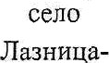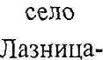

***ceno***

ceno

**flb3HR$b-**

sezo

JIgSzHqa-

ceno

ceno

JIWHnila-

ceno

Jlaannqa-

ceno

ceso

ceno

Jl8SiiHpa-

ceno

Hasxzua- ceno

JJaziiiitta- ceno

*ceno*

327

528

330

331

332

333

#### 334

335

336

337

338

339

340

#### 341

342

343

346

347

348

349

350

351

352

353

0,2102

0,7000

0,0670

0,0048

0,1596

0,4710

0,0850

0,7176

1,1928

5,2798

1,8632

1,2986

0,0350

1,3270

0,0232

0,2848

0,4703

1,7466

0,2247

1,0551

0,2i32

4,2644

0,9907

1,7776

0,3370

0,5715

t 1,943\

7.097,05

8. l 10,40

3,548,51

8.110,42

1.524,62

8.110,40

8.110,35

8.110,40

2.679,91

2.872,47

2.872,47

3.237,59

2.365,43

2.872,47

4 731,03

4 730,90

1.456,28

2.365,44

2.365,42

2.872,47

2.365,43

3.068,88

4.730,89

1.824,6t

1.824,60

3.492,18

t 2.365,44

745,90 15

2.838,64 15

1 I 8,88

19,46 l5

145,60 15

1.910,00 15

344,69 15

2.910,01 15

1.598,30 15

7.583,03 15

2.675,99 15

2.102,17 1S

41,40 15

1.905,88 15

54,88 15

673,68 15

342,44 15

2.0b5,74 15

265,76 15

1.515,37 15

252,16 l5

6.543,48 15

2.343,45 15

1.621,71 15

307,45

997,89 15

2.298,14 15

ManH **KaMeH** Mann **SM9H**

|  |  |  |  |  |  |
| --- | --- | --- | --- | --- | --- |
| 354 | 0,2039 | 8.242,67 | 840,34 | IS |  |
| 355 | 1,1845 | 861,76 | 510,37 | 15 | 2. aoxa |
| 356 | 3,3845 | 1.436,26 | 2.430,51 | 15 | 3. ooHa |
| 357 | 3,2890 | 1.436,26 | 2.361,92 | 15 | 3. fora |
| 358 | 16,1247 | 1.824,61 | 14.710,64 | l5 |  |
| 359 | 2,1347 | 1.436,26 | 1.532,99 | 15 |  |
| 360 | 0,7445 | 1.436,25 | 534,65 | 15 | 3. noma |
| 36t | 1,1643 | 1.436,25 | 836,12 | 15 | 3. bona |
| 362 | 0,1392 | 1 436,28 | 99,96 | *11* | 3. aoza |
| 363 | 4,2663 | 861,75 | 1.838,25 | 15 | 2. noma |
| 364 | Q,3708 | 1.436,25 | 266,28 | 15 | 3. soiia |
| 365 | 6,6662 | L149,27 | 3.830,63 | 15 |  |
| 366 | 1,0941 | 1.436,26 | 785,70 | 15 | 3. Moira |
| 367 | 3,0475 | 1.149,27 | 1.751,20 | 15 |  |
| 368 | 1,0656 | 861,76 | 459,14 | 15 | 2. bona |
| 369 | 0,|193 | 1.436,30 | 85,67 | 15 | 3.3oua |
| 370 | 0,6528 | 1.436,26 | 468,79 | 15 | 3. Moira |
| 371 | 1,1549 | 1.436,25 | 829,37 | 15 | 3. fora |

KaMDH

Manx Karieii

**KaMPH**

## Ma»

**KuMUH**

Mann Kaugz

Mann

KaMea

Mea Kartex

Mann Kauert

Mmm

15 3. 3ona

l5 3. Rosa

|  |  |  |  |
| --- | --- | --- | --- |
| 372 | 2,4277 | 1.436,26 | 1.743,40 |
| 373 | 0,6167 | 1.436,26 | 442,87 |

3. sona

|  |  |  |  |  |  |
| --- | --- | --- | --- | --- | --- |
| Mann | 374 | 0,8940 | 1.436,25 | 642,01 | 15 |
|  |  | 0.0150 | 1.824,67 | 13,68 | 15 |
|  |  | n 03s1 | 2.049.91 | 59,55 | 15 |
|  |  | Q 1447 | 4.442,71 | 321,43 | 15 |

0,4100

0,7303

0.1182

0,1070

0,2347

^Rn s? 1.436,26

1.436,29

1.824,58

2.049,94

294.43

524.45

84,88

°* ^2 240,56

15 3. ^ " a

s1 3 ° " a

15  ~~"°*^~~  J5

15



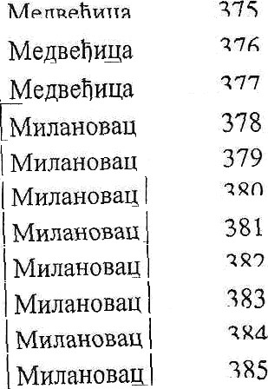

|  |  |  |
| --- | --- | --- |
| 8,2626 | 1824,61 |  |
| 1,1507 | 2.482,41 | ) i avs 25 15 |
| 0,0150 | 4.730,67 | I 35,48 15 |

|  |  |  |  |  |  |  |  |  |
| --- | --- | --- | --- | --- | --- | --- | --- | --- |
| MttnaiioBait | ?86 |  | 0 s2g | 2.872,47 I | 759,62 l5 | | |  |
| MonaiioBa | 387 |  | 1,0269 | 5.409,20 | 2 77’7,j5 15 | | |
| M cdHOBR/ | 388 | | | 0,5558 | 7.097,03 | 1 972,27 l5 | | |
| MMrazoeag | 389 |  | 0,0901 | 2.365,48 | 106.56 15 | | |
| MiinaaoBaii | 390 | i,21l6 | | 1.436,26 | 870,08 | 15 | 3. Moira | |
| Mu0dTOJ3dii | 391 | 0,1395 | | 1.824,59 | 127,27 | 15 |  | |
| MHnaToaaq | 392 | 11881 | | 4.193,79 | 2.491,32 | 15 |  | |

KHJIdTOBd t 393 0,0300

M8naioaait 394 | 0,5886

MflnaToBap 395 0,3376

MonaTo8ap 396 0,1427

MllnaToaaq 397 0p8447

ManaToBay 398 0,3188

MzndTOBd/ 399 0,1178

MHxaioBau 400 0,3105

MrnaroBaq 401 0,6500

Mznaioaau 402 0,0314

OGdHHUfi 403 1,6819

Ocaaripa 404 0,7414

Ocauzua 405 0,3432

Ocaiizpa 406 0,7041

Ocaaxga 407 0,1462

Ocatiztta 408 I 0,0681

Ocaazua 409 1,6913

Ocaiirpa 410 02006

411 1,5974

b.110,33 121,66 15

7.561,88 2.225,46 15 1

5.717,65 965,14 1 15

8.110,37 578,68 15

2.36544 999,04 15

7 097.05 1 13 l,j7 15

8 11044 477,70 15

g i io,io 1 1.259,14 | 15

5,744,95 1.867,11 15

g.l i 0,51 1 127,33 15 1

4.730,89 3,978,44 15 I

2.365,44 876,87 15

4.730,89 811,82 15

2.87248 1.011,25 | 15

1.824f›2 133,38 15

2.365,49 80,54 15

6.786,39 5.738,91 13

1.824,63 183,01 1 15

3.939,79 3.146 71 15

Ocaiiflud Ocaiiriqa Ocaiizua Ocau«ua Ocaaxua Ocaiixua

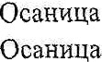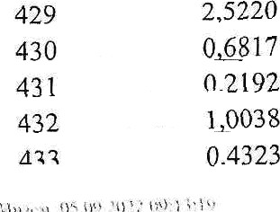

Ocaiiz9a Ocaiixpa

Ocaii»ua Ocauiiua Ocaiixua

Ocauqua

412 0,0578

413 0,283 l

414 0,9093

415 1 0293

416 1,4578

417 0 1051

418 1 1218

419 0,6939

420 0,3500

421 0.6 eg

4ao 0.4600

d73 0.2383

424 <<>+

ao s 0.3890

426 7<<+

427 0.6330

428 0,1670

1.824,57 52,73 15

7.097,03 1.004,59 15

2.36543 1.075,45 15

7.875,19 4.052,96 15

4.113,42 2,998,28 15

5 592,10 293,86 1 15

5.48917 3.078,88 15

3.250,40 1.127,72 15

2.573 60 450,38 15

3.344,35 1.109,99 l5

2.660.28 611,87 15

2.872,47 342,25 15

2.365.44 109,17 15

4,730 90 920,16 15

2,872.47 2.499,77 15

7 365.43 748,66 15

7.097 07 592,60 ! 5

2 365.44 2.982,82 15

a u a sa 1.112,65 15

4.562,59 500,06 15

2.365,44 L187,21 15

8.110,41 1.753,06 15

Ocaoxua Pii6ane PwfirJ ne

Pii6ape

###### Po6ane

Pa6aoe

PFt6ape Pofi:«ae Pufiape

D«6ape P«6pe

434

435

436

437

438

439

440

441

442

443

444

445

446

447

448

449

450

451

452

453

454

455

456

457

458

459

460

461

462

463

464

46s

468

d7fi

471

473

474

475

476

477

d78

479

480

dg

0,3835

0,4073

0.2809

0,0670

0,2444

0,0754

0,7153

0,9266

0,5599

0,3000

0,0304

0,0700

0,5150

0,3350

0,0220

0,0609

0,0795

1 5000

0,3092

1,2236

0.1029

0.1047

0.2557

0.0724

0.1327

0.2992

0.0659 0,0242 0,7400 0,5623 0.2341 0.0610 0.5882

0,2241

2.5268

0 4152

2.5952

0.7847

n ?576

2,4101

0,7 006

0,1713

0,0533

0,0300

0 7627

0,2000

1,0295

6.825,48

3.548,51

7.097,05

4.730,90

2.872,46

4.730,90

4.730,90

2.872,47

4.999.84

7.097,03

1.824.67

7.097,00

4.562,58

8.110.39

1.824,55

4.730,87

4.730,94

2.365.44

2.365.43

2.365,44

2.365,40

2.365,43

2.365,43

4.730,94

6.530,14

7.097.03

2.365,40

2.365,29

2.365,45

2.872,47

2.365,44

7.097.OS

8.11040

8. 110.46

2.872,47

9.124,46

6.713.85

6.826,58

7.792,09

2.365,44

2.049,97

fi 488.56

1.824,67

7.097,05

5.744,95

1.308,78 15

722,66 i5

996.78 15

138,48 15

351,02 15

178,35 15

1.692,00 15

1.330,82 15

1,399,71 15

1.064,56 15

27.73 15

248,40 15

I.174.86 15

1.358,49 15

2007 15

144.06 15

188,05 15

1.774.08 15

365,70 15

1.447,18 15

121,70 15

123,83 15

302,42 15

171,26 15

433 27 15

1.061,72 15

77,94 15

28,62 15

875p21 15

807 59 15

276,87 15

216,46 15

2.385,27 l5

310,22 15

321,86 15

I 1.527,84 i 5

1.393 0 15

8.858,17 15

3.057,23 15

304,55 15

175,58

172,92

27,37

TO9 7O

2.957.21 15

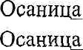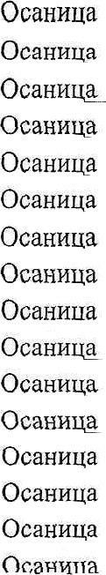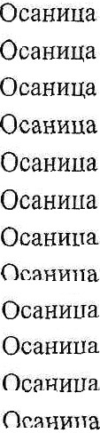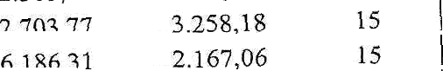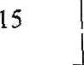



|  |  |  |  |  |  |  |  |
| --- | --- | --- | --- | --- | --- | --- | --- |
| Px6ape Pz6ape Pz6aoe Px6ape P116ape Care Care C«re Care Cxrc CyBH Q,O  Cyaz fio Cyao ,Qo Cpu ,Qo C9BD TO  Cyaz ,Qo CyBD TO  Cyzn ,Jo Cvaz to AVBH JO  Cysx ,Qo Cvcz to Cysx ,Qo two fio Cvax to Cyan to Cvaz to Ivan Fo CUBE JJn  Over In Lync In PART ICI  Uv« no Gym On c» to NVBH TO  C Blt ,QO  Cy Bp ,Qo CyBH JO  Cvrz to CyB11 JO CyBT1 @O CyBT1 JO CY8H JO | 482  483  484  485  486  487  488  4b9 490  491  492  493  454  495  496  497  498  499  500  501  502  503  504  505  506  507  508  509  510  511  6 12  b 1 3  s i 4 s s  516  517  b ”'  521  522  523  524  525 | 0,1881  1,1658  0.1529  0,2331  0,1954  0,2664  0.4202  0.7505  0.0729  0,0590  2,6032  2,3500  1,9443  0,4650  1,8626  1,9485  1.5302  1,7872  0,6781  0,2069  1,9592  1,4376  0,0900  1.0940  3,4948  0.9358  1.5090  1.1548  0.1455  39.6014  3.9112  1,0356  0,9890  1.0925  0,8268  0.9743  0.9717  1.9448  0.*249  0,0912  0 4fi33  0,3 222  0,3619  0,4342 | 2.365.44  7.097.04  7.097.06  7.097.04  9.124,46  7.097,03  5.744,95  4,730.89  7.096.98  5.744,92  8.954,55  8.600,52  7.606,13  8.110.41  9.124.46  1.746g02  2,190.27  1.436,26  1.436.26  1.436.25  9.124,46  4.960.49  2.872,44  1.436,25  2.047,72  5.109.95  1.436.26  4.161.21  1.436.29  1.688,13  1.436,26  1.436,26  1.436,26  1.436,26  1,436,26  1.436,25  2.872,47  3.548,52  S.110,40  i s ›s  1.436,26  1 4 .25  1.436,25  1.436.25  1.436,25 | 222.47  4.136.86  J42.J7 827.16  891.46  945,33  1.207,01  1.846.23  258,69  169,48  11.655 24  10,105,61  7.394,29  1,885.67  8.497.61  1.701,06  1.675.77  1.283,44  486.96  148,58  8.938g32  3.565,60  129,26  785,63  3.578,18  2.390,94  1.083,66  2.402,68  l 04,49  33.426,18  2.808.74  743,69  710,23  784,56  593,j5  699,67  1.395,59  3.450,58  912 01  65.49  332,71  23 i ,3g  259.89  31 i ,s i 480,14 | 15  15  15  15  15  15  15  15  15  15  15  15  15  15  15  15 3. noma  15 3. soda  15 3. sona  15 3. soHa  15 3. soda 15  15  15  15 3. Moira  15 3. Moira 15  15 3. 3oiia  15  15 3. soda  15 3. Moira  15 3. soHa  15 3. noma  15 3. aorta  15 3. noma  15 3. aorta  15 3. noma 15  15  15  15 3. sort a  15 3. coca  15 3. sona  i5 3. Moira  15 3. coca  s 3. 3oHa |  |  |
| CyBR @O | °° | 3 552 I | 1.436,26 | 2,550,86 | 15 3. Moira |  |  |
|  |  |  | o i va 49 | 562.52 | 15 |  |  |
|  |  |  | 8.110,47 | 104,62 | 15 |  |  |



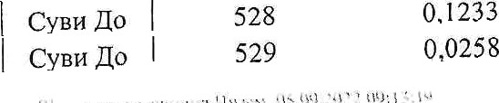



|  |  |  |  |  |  |  |
| --- | --- | --- | --- | --- | --- | --- |
| Cezflo | 530 | 0,2036 | 9.124 46 | 928,87 | 15 |  |
| Cy bo | 53 I | 0p5200 | 1.436,25 | 373,43 | 15 | 3. noma |
| MBH 0 | 532 | 0,4100 | L436,27 | 294p43 | 15 | 3. fora |
| Cyar Qo |  | 1,5440 | 1.436,26 | 1.108,79 | 15 | 3. fora |
| Cyaa ,Qo | **534** | 1.8036 | 1.436,26 | 1.295,22 | 15 | 3. noma |
| Cyzii Jo | 535 | 0,1500 | 1.436,27 | 107,72 | l5 | 3. soda |
| Cyb o | 536 | 0,0744 | 8.110 35 | 301,71 | 15 |  |
| C_yaa Qp | 537 | 3,2d38 | 9.3l7p76 | 15.298,83 | 15 |  |
| Cyex fio | 538 | 0,0500 | 9.124,40 | 228,11 | 15 |  |
| CyB8 JO | 539 | 0,2695 | 9.124,45 | 1.229,52 | 15 |  |
| Cyzn fio | 540 | 0,4129 | 9.124,46 | 1.883,74 | 15 |  |
| Cyan Jo | 541 | 0,0078 | 9.124,36 | 35,59 | 15 |  |
| Cyaz Qo | 542 | 0,1357 | 4.562 56 | 309,57 | 15 |  |
| Cyaz ,Qo | 543 | 0,1802 | 7.097_,06 | 639,44 | 15 |  |
| Cyaz Jo | 544 | 0,2524 | 8.110,38 | 1.023,53 | 15 |  |
| Cyuo ,Rio | 545 | 0,0781 | 6.559,54 | 256,15 | 15 |  |
| Cyzz ,Qo | 546 | 0,5024 | 6.087,88 | 1.529,28 | 15 |  |
| Cyzz Qo | 547 | 1,9188 | 2.365,44 | 2.269,40 | 15 |  |
| Cyaz Qo | 548 | 0,4578 | 5.744,95 | 1.315,02 | 15 |  |
| Cyax ,Qo | 549 | 0,2802 | 2.365,45 | 331,40 | 15 |  |
| Cviz ,Qo | 550 | 1541507 | 1.436,26 | 110.699,99 | 15 | 3. fora |
| Cyrz fio | 551 | 0,3211 | 1.436,25 | 230,59 | 15 | 3. soda |
| CyBit 9o | 552 | 0 9655 | 3.824,33 | 1.846,19 | 15 |  |
| CYST @O | 553 | 0,2781 | 1.436,25 | 199,71 | 15 | 3. aorta |
| Cya4 @O | 554 | 0,0327 | 5.125,38 | 83,80 | 15 |  |
|  |  | 747,6647 |  |  |  |  |

* 1. Ysr1p y poxyueHzaitujy: rpaQHuxn npernep xaiacTapcxiix napitena no xatacTapcxiiu oriurrwriaua z cnzcax riapueoa no QopMiipaxiiu ja**Bxiie** iiaqivieramxma (xoMnnexcnua), xoja cy npequei iispasaisa y zaxJH it «a xopzuiheme, more ce iizB llJHTEt y urpapn oniiiTxiie MFYbH tA, y zaHqenapiijz 6p 12 ceaxor panaor Maria ou 10 go 12 oacoza , xao z za ae6 ripmennuvijn YnpaBe sa nouonpzBpefno seuwriuiTe.

Koirraxr oco6a 3Be3paHiia BaczneBzh lIlhonynoBah, Ten. 0628098314.

3, 3euwz iTe ii3 oBOr Ornaca naje ce y Bz3eHoM cTaisy.

* + 1. O6onaoai‹ nononpazpea«o 3 )qxiuia, i‹oje ce naje y » 2gyri ii tia xopiiuiherbe no;›xe ce

H3BQMWTH'

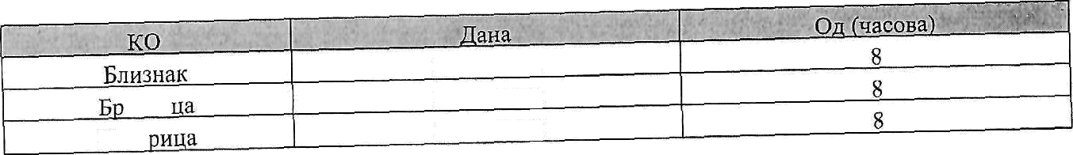

esiin

**/3Bb**

12.09.2022

12.09.2022

12.09.2022

t S

„„„, „«. ., ‹1.'..'""'"."›"""'’""



|  |  |  |
| --- | --- | --- |
| Jouiairxqa | 12.09.2022 | 8 |
| K@enonzu | 12.09.2022 |  |
| Kpynaja | 12.09.2022 |  |
| Hasiiriqa-CeziiiiiTe | 12.09.2022 | 8 |
| Jlmuiiqa-ceno | 12.09.2022 | 8 |
| *Mzsz* KaMeH | 12.09.2022 | 8 |
| Mepaebxya | 12.09.2022 | 8 |
| Miisarioaau | 12.09.2022 | 8 |
| M«fla*oBau | 12.09.2022 | 8 |
| Ocaozua | T2.09.2022 | 8 |
| Pz6ape | 12.09.2022 | 8 |
| Care | 12.09.2022 | 8 |
| C\BT4/O | 12.09.2022 | 8 |
| ByKOBdU | 12.09,2022 | 8 |
| Vary6HuS | 12.09.2022 | 8 |

* + 1. KOnOxo naxon pacnriciiuaa a Oroaca sa ja Biro HapMeiaise sa aaxyn ii na xopoiuheise noaonpiiBpeqiior seuuiiiirra y qp aziioj cBojiion nolje go npoMeiia riOBQiuxiie nz orzaca no 6xzo soM oaxoiicxou ociioBy, pan,ii nocTynax pazarsa riouonpzape nor 3eMnituiTa y saxyn z sa xopiiiuheme he ce cnpoaeciii G£tMO 3a iaxo yiBp§eny noapuiMHJ 3eMJbM11lTS.
    2. Cue ouixOBD Kojz HaciaHy no ocrosy saxyna ii xopaiiihersa no onpriB HB egaor seMu iTa y ;jp1tazHoj cBojxiiu cxocu sure xoje Jo6iije zo zeuJbiuiiTe y saI‹yn, oprtocno Ha xopxufiieise.
    3. 3euuxurrS H3 OBor Orflaca paje ce y 3axyn a tia xopiiuihene zci‹nysoao sa non.onpnB epry

n§0H3«ogay, me nome ce ‹opricTirrn y ppyre cBpxe.

* + 1. How.onpiiBpenzo seMwxiirre y npwaarioj czojurtir rpyriiicario y jecriiHqe jaBHiix iiapMeTaisa osHa'ieiizx * vi ** y ia6eno iauxe 1. oBOr Ornaca xiije 6»no risqaio riajMame nocnepise cpu arpoexoHoMcxe routine x niije 6aoo rrpenrieT xopiiuilie+a.
    2. 3CMJfix££lTfl 03 OBOr ornaca me more ce gaeaTz y nopsaxyn.



1. HpaBo y'ieiiiha y jaBuoo iiapveraisy sa paaarse y saxyn nononprtapepuor meminta y ppmaaiioj

csojnint rlMa'

-Qzaxzxco u npaBxo ringe noje je yniicaiio y Perticyap non.onpriBpeqiizx rmpiiHcTaBa H iianmn ce y

amiiBHOu ciarycy HajMaue rpm ropnee.

1. HpaBo y'iettiha y jaazou xanuciatsy sa pazaise ea zopzuiheae nononpirnpeqxor seuuzmia y

gp+aaHoj caojnzil sa 6pojeze je,gxiixita jaBiixx nanueTarsa o3raxenzx * Pi ** y n6enH ia'nte 1.

oBor orzaca xMa:

-3a 6pojeze jepzHzpa

ja Biizx oaqMeTaaa osrta'iertzx * y *Ta6enii* Taxxe 1. oBOr ornaca Hxa Qx3rtHxo

x raspnHGTñBft H «wazit ce y

z npaario urge xoje je yniicaHo y Perrrczap nou onpngpegiiz



-3a 6p

uapMeiarba osna'ieiiHx ** y Ta6erii ra'iKe 1. oaor ornaca iiMa npaBiio

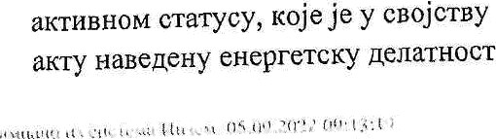rxue n npeny3eiiiux xoje je ynucaH0 y Perzciap noaonpzBpepiuix rmpioici asa ii canon ce y



nperea‹iie ,aenaziiociu periicrposaHo ttn0 Etna y ociioa6HKOM

nponiicaay saxoaori xojzri ce ypeijyje o6nacr eueprerzxe, a

sa xiije o6aBaaise ce i‹opucie o6oOBJ£'flBD H3B0§fl Oz 6xouace u cTo'iapcTaa a na y poKy og Tpu roniiiie og mana saxny'ieisa yroBopa o xoptimheisy seuuiiniTa pociasz qoxaz o npz6aan›eiioj ynoipe6ii0j possorii 3a exepreicxz o6jeKaT za uzjz pay ce nnazzpa xopiiuiheise o6xorn,rBiix iioaopa og 6nouace xojH rnacii Ha zMe saga ca xojxu je saxuy'iert yroaop *o* xopomheisy, y cynpotiiou *yroeop* npeciaje pa aamir, a Perzcipo Barrow nomonpnBpepiioM raspiiHczBy ce yTapijyje naczsaH cTaTyc .

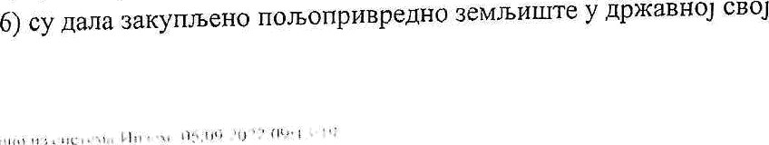

1. Ilocynax jaraor aa@Meraisa cnpOBO@ii ce enettTponc‹no uyieri, npeito oe6-anniixaqitje oa cnposo1je+se jaBnor iiagrierarsa - https://gp.upz.minpo1j.gov.rs/InzemBid (y nmeM ieKciy: Ansoxauzja) xoja ce xnmz Ha ssaHD'llt0j Be6-iipeseoTaitojn YnpaBe sa noaonpiiapenno aeMnziirre.
2. fIociynai‹ jaaiior ira,qMeiarsa oppn‹aaa ce axo je 6zaroapeueiio pociaaneoa iiajMarse jepiia ype,qiia nprijaBa ma jaai+rr ornac y Annrr«aqzjz aa cnpoBoljerse jasiior ra,gueiaisa z axo ce nocTaBx noi‹as o ynnaiii ,genouwra oa caaKo jaBiio ma eTarse riojepiiHa'iHo.

HoHylja» je py an pa aajeqiio ca npxjaaou sa jasiio HanMeTaae pocTaBz poKas o yrizaTii qeno3riTa y iarxow Hapcrou nsnoey iiaBegeiiou y ia6ezz iasxe 1. oaor orzaca, sa cBaxo janiio iiapveian.e nojegznd«HO, Ha paoyz onuiiiiiicne ynpaBe HAMEHljA 6poj: 840-1229804-14, oGiiM axo je sa jepiiniiqy jaBHor HacMeyaisa yiapijer iisxoc perioattTa watsz o 1.000 nzzapa, nonylja'i *we* uopa pa yrinaiii penosfli ii goczaBii your pane ysemha ma jaziiou HapMeTaay 3a jeniiiiiiiiy j8BH0£' HapoeTarsa.

6. Cert noiiyljasHua, oczri aajnoaon.uzjev, ynnaheuii qenosirr he ce Bpanrrz mar on jaBiior zagrieiaisa. Hajnozon,iiiijev noiiyljay AenoseT he *6*irr+i ypa'iyxaz y ro uiu,y zaxyniiziiy. Axo iinjnoaouoxjx noxytja'i onycTaiie on cBoje noiiype genozei ce He apaha.

Hajnoaouiizj» norrylja'i jecie nony1ja'i xojii xcriywaaa ycuoae sa Karyn o xopnniheae riouonpxBpeqiior seunxuiTa xz saxoita cojiiM ce ype{yje nouonpzzpe,4iio seMJbxuiTe a noiiym iiajBiiiry qeiiy saxyna sa jepziinuy jaznor Hauueiaisa.

1. AKo ce sa jepiiiiinty ja BiiOf' Ha ezarsa npiijaari artine y'iecnr1xa xoju ncnyuaBajy ycooae sa

3axyn ii KObniiiheae oon›onpiiBpepuor 3euuiii Ta H xoja cy nor+yniisa iiajBilly itchy saxyna y HcTOM iisoocy, paje ce y saxyn ouOM noiiy§a'iy xiija je npujaBa upBa npHcTHrna y Anniixauzjy.

1. Ilpazo saxyna z KOQnuiheisa noaonpiiBpenuor seuuiniiTa y gpmaBiioj cBojonit Meoajy npazHa ir Qiisz'itta area yniicaiia y Perzciap nouonpxapepnxx raSQHHGTaBa xoja:

###### cy y nacnBn0u cTarycy;

* 1. iizcy acnynzna cBe o6aBese ua nperxoqiixx no Teityfiiix yroBopa o 3axyny riouonpxzpepror

oeMuaiirra y ppmaBnoj caojzrH;

* 1. GJ Plzapuizna ooezarse rioceaa noa oripiizpeqnor oeuaiiuiTa y gpmaziioj caojriiii;
  2. cy irapym9aaJia uecrierario OpBiijaise 6ozo xor Mena nocTynxa jaaiior xanMeTarsa ripiinHxOM

qaearsa riou 0npi iBpeniior TeriuzuiTa y npmaBnoj GBO)itnii y 3axyri;

y ,O,pwaeHoj cBojzHz;

xiiii y rioqsaxyn.



1. Ptcnyiseiioci ycnoBa sa ripiijaauiiaaise ma jaaiio iianueraae 3a 3dxyri n0JbOlI§oB§epiior meminta

y qp aaHO] GBOjHxii nouyljas noxasyje cxepelioM poxyMeHaia iijoM:

* + aa Qanieso ma:qe:

-noiappa o arrmooM ciarycy x3 PeriicTpa nouonpiiB PQHtlx rW,dHncTaBa sa Tpn routine;

-n»xHa xapTa max oxxraHa cttxna xapm sa nzviie xapze ca xiinoM.

* + 3 **op8eao we:**

-noirppa o axixsHou ctaTycy ma Perxctpa noaoiipzapepiiiix rasn liicTaBa 3a cpu ropitxe;

-D3BO,Q Ha nQiiBpepeor periicrpa (me Graprijii on iiiecT Meceq«).

1. llciiyneaoci ycnoza ua npiijaBn.raise sa xopzuiheise nouonpzape or 3eMuiiurra y ppwasiioj ceojpzz aa nononpHzpepHy npoinBoprsy aa 6pojeBe jepiiiin a jaan IX HanMeiaisa o4iiaoeriii * y Ta6eflH iasxe 1. oBOr ornaca noiiy1;a'i poxmyje cnepehoM poxyMeHaiauHjou:

-sa Qmws s pa uuoxou rapzoM Ann ooriT£tHOM JIHHHOM xapiori oa nii'iiie xapTe ca xoriou ii I10TB COM 0 tenor ciarycy y PeriicTpy nouonpiizpeqiiiix rasQDMTTñBH ;

- sa **npasaa** nuzta iiseoqoo us npxapepiior perrtcipa (ee cTapujii oq itteci oeceuii) ii noiapnori o

aziiiBeov cTarycy y Perncrpy rrouonpzapepiixx raspaiiciaBa;

1. ilcnyiseHocT yczoaa 3fi ripiijazuiiaaise ma jaaro xaqMeTane sa xopriuiheise nononpzBpepzor 3eMomiiTa y ,qpafQBiiOj cBojiriiii sa npoiisBopisy exeprnje us O6HOBJbHBHX xsBopa og 6zoMace z

cio apCTBa nouylja'i sa 6pojeBe jeAzazua jaBiiHx HddMerarsa osaa'ierinx ** Ta6enx ya'ixe 1. oaor orzaca

poxa3yje cnenehov now eiiaiaitnjou:

-POTBp,dOM 0 HSzuaiiou cTaTycy y Perucipy non,onpxapepuux rasgxitciaea;

-iisnopori xz npozpepiior perrcTpa (xe cTapriju og niece ueceitrt), opooczo ociizBanxuu arrow Rao qoxa3 qa je periicTposaxo sa eriepreTcEy perdTitocr sa 'inje o6aBmatse ce xopxcTe o6zOBWiiBH it8BO it OQ 6H0M8GD a CTOuapcTza.

flozyljas ce npxjaBayje a uprate cxeuzpaiiy, O,dHOczo QOTorpaQxcaiiy noxyveoyaqiijy xojou qoxmyje iicnyiseeoci ycuoaa oa ocraapiiBaise ripaBa saxyna x xopzuiheisa nyieu Annzxauiije , x TO:

1. 3a saicyn nonoriprf Bpepnor zeuau»rra y ppmaBHoj caojiion qoxyMeHiaqiijy xaBepeHy y deny III Ta'ixa 1.

OBO£' Ornaca it goxas o ynnaTH @flHO3HTA;

1. aa Koprtuiheise noaonpvtapepnor zeuwxurra y qpmazHoj czojoiiz sa nouonpriBpepay npoii3Boprsy noxyneuTaitujy HaBegeHy y deny Ill iauza 2. oBOr ornaca;
2. 3a ropxuihen›e noaonpnBpenH0F 3flMa»mn y ppztaBooj cBojziix sa npoii3sopisy eHepFiije ii3

o6noaJbvtBzx ii3zopa or 6iiovace ri cio'iapcTza roi‹yMeirra9xjy HaBeqeHy y deny III Tauita 3. oBOr ornaca;

nooy5a'i oproBapa ss ia'ipoci noAaiana xoje yiiocx y Anz«xaqiij y, xao x ua Bepon ocrojxo ci ldGnpaBa zoje npxnante, a xoje uopajy ,qa 6yAys rtiuzBe.



Pox sa npitjaanxBame a nonaouierse pozyweiiTauaje AftJ1in‹aitojy je go 12:00 GATE, @aHa i4.09.2022. roAxHe.



Henornyoe npiijaae aehe ce pa3uaTpaTii.

Jeuiiov riopiiera npiijaaa ca noHypou xe more ce Meisazn,

V

OiBapame nozypa sa paBaise y saxyn H ma xopamheise seuumirra rio Jena I. ianxe 1. oBor oruaca

onpuahe, z to:

|  |  |  |  |  |  |  |  |  |
| --- | --- | --- | --- | --- | --- | --- | --- | --- |
|  | . | , . . | ' | - |  |  | . i• w' |  |
|  |  |  | |
| 6fH3H8K | | 23.09.2022 | | | | | 12:00 | |
| Spe3um a | | 23.09.2022 | | | | | 12:00 | |
| lfoaapopa | | 23.09.2022 | | | | | 12:00 | |
| Joiiiaazita | | 23.09.2022 | | | | | 12:00 | |
| K *enoaiio* | | 23.09.2022 | | | | | 12:00 | |
| Kp yriaia | | 23.09.2022 | | | | | 12:00 | |
| JJmiiiiua-Ceniiurre | | 23.09.2022 | | | | | 12:00 | |
| Hmiiiiqa-ceno | | 23.09.2022 | | | | | 12:00 | |
| Mann Kanes | | 23.09.2022 | | | | | 12:00 | |
| Mepze5za | | 23.09.2022 | | | | | 12:00 | |
| MnxdHOBb/ | | 23.09.2022 | | | | | 12:00 | |
| MitnaioBa/ | | 23.09.2022 | | | | | 12:00 | |
| Ocazoita | | 23.09.2022 | | | | | 12:00 | |
| Pn6ape | | 23.09.2022 | | | | | 12:00 | |
| Crire | | 23.09.2022 | | | | | 12:00 | |
| Cyaz ,Qo | | 23.09.2022 | | | | | 12:00 | |
| BYxo Bay | | 23.09.2022 | | | | | 12:00 | |
| Hary6iipa | | 23.09.2022 | | | | | 12:00 | |

Haxox zcTexa poxa aa npnjaBy zz nena lV oBOr oI’naca, a ripe nama oppeljeiior oa oTBapaise noiiypa z3 Jena V oBor ornaca, na emaz opraii jenzonpe noxmiie carioynpaBe yap{yje nerryrseHoei ycnoBa sa ocirapxsaise npaBa z axytia z xopiiuihers a cBxx noquo c»uapa camera pa ociioay qoxyveHiaqzj e npHnozieze y AnniixattzjH.

###### Ha can oi«apaisa noeyna, n3 Mena V oaor ornaca, in Annrixaunje ce ripexa eiicnHii noHyne ayrouaxcint 0 Mrtpa pair nzcTa nozyljasa aa xoje je yrsp3ezo ca iicnyaaBajy ycuoze aa saxyn H

KO oNeae no onpuB epzor 3eiin.iiuiTa.

Parrr enema noiiy a'ia o6jaBnyje ce ma 3BaHxnHoj Be6 — ripeoeuTaitiijii Ynpaee sa non.onpnapeqrio aeriaxurrer caApmri TTIlGax Bupa i‹ojH xcnyisaBajy ycnoBe za ocia apvigarse npaBa oaxyna ri xopiiiuhersa p q pPi gpe piior zeriuinuia paiirxpartiix npeua aricxmi noiiype, zpeve pocTaae aaxiesa ii cn;icax Unita



xojii He iicnymaBajy ycuo Be aa ocizaprBarse npaaa saxyria riouonp



noriypa

3axyniiziia ce rniaha yxanpe,g y pnHapcxoj npoTzBB ennocin rio cpe,qioem xypcy Hapoqiie 6aiixe Cpfizje

##### ma can yosdie.



Hajrtozouwjz nozyljau je y o6azeon Aa y poxy op 8 paHa op npaBiiocoavaoCTii onsyxe nocTaBx poKa3 o ynnaTii c axyniiitHe y iiaHocy yiBp§eiiou npaaocoawiiou opnyxo M o qaBaisy y 3axyrt fTOJfiOnpHzpeqHor sevw riiirr a y npmaBHoj czojarts, yriaweao;vt aa xzuoc yrinaheiior genosirra, «oje he Q0GTaBtITH MriHiicTapcTay nowonp uBpe,4e, iiiyuapcTB a ii aononpiispepe ripexo onuiziiacxe ynpaBe oriurrxze MFYh IIIA.

Yxonrxo je nepiion zaKyna py ztH O,zt jcone ronoite, saxyniiiiHa ce usaha iiajxaciizje o 30.cenTex6pa sa cBaxy oapepuy romany saKyna, a ya ynnaTiinity za npay ropzny 3azyna iiorpe6iio je

pocTaBxTtl If :

rapauqiijy nocnoBiie 6aHi‹e y BriCRrii rouoiiirse aaxyniiiiiie nouonpxapepuor

zgunziiiTa one

- yroaop o jeocTBy risuefjy MxoitcTapcTza Rao noBepzoua z npaeuor mrna «ao jeMqa ii *yw*

AOxas o yrisaTii pgriouirra y anchor jepue ropxiuise sanyniiriiie xao cpepcmo o6es6e3ersa iinahatsa saxyriiioae, a xojz he ce y cnysajy peqoarior nnahana panyuaTH Kao nnaheua sazynuiina aa nocnepay ropiiHy saxyna

OBy oAnyzy o6jaBiiTii xa *ee6* npesexTapxjii YnpaBe sa nouonpaapentto oeMniinrre, y cnyv6enoo ruaciizy jegiiiiHue ooi‹aaiie caooyrrpaBe, ma ornaciioj ia6rz x samiriooj Be6 npese›rrauujn onumiiie zArw A, c TiiM uiTo he ce pox sa no oiueise riprjaae paxyiiam op mana o6jaBazzarsa ma *ee6* rrpezeiiTaitxjz YnpaBe 3a nononpviBpepxo seMuzurre. Oaa opnyxa ce more o6)azm ii y upyrRM cpepcTBrua jaBiior riHQOpMrrcarsa, into tie yiroe na nociyna« jaa«or uapueraisa.

PBfIYbJIHKA CP£HJA

##### OIBIITHHA tA 'V •

Ilpencefgnx o nmiae

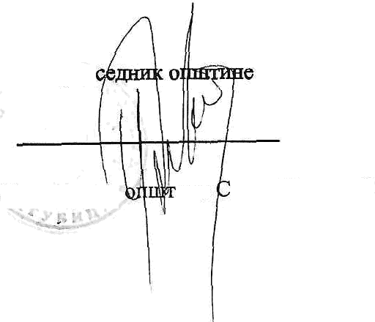

Hpep

Hpepcepeux

aHe abet nannoziih

bpoj: 1-01-320-731-22/2022

java: 02,09.2022. rope

20

OCHHBA'I:

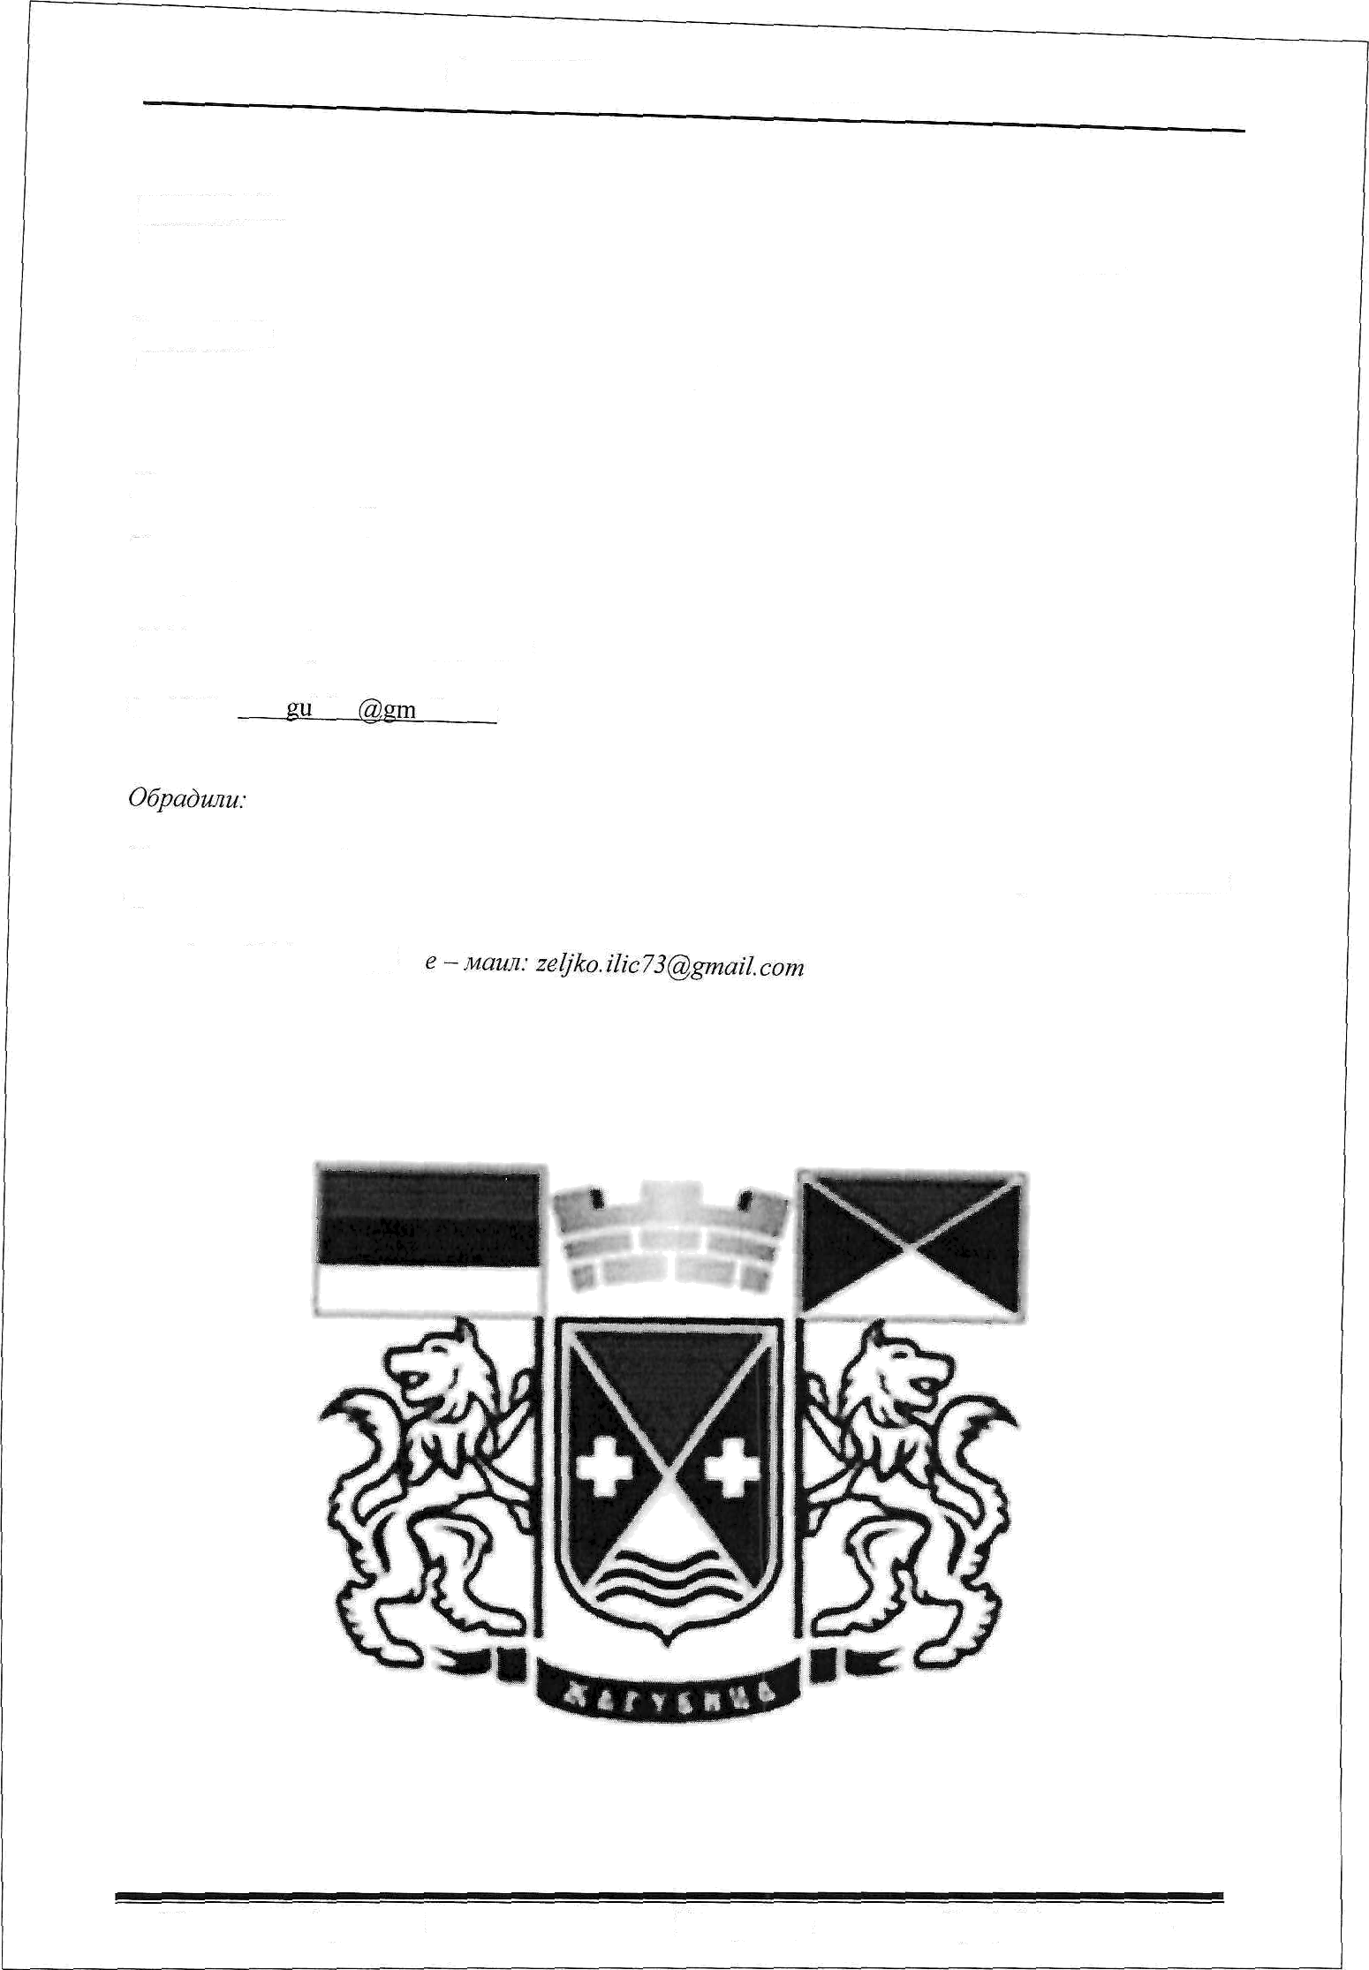

*CKFHIIITHM OHIHTHHE If B*ff*IfA,* Opnyra 6p. 1-020-542/06-01 ou 3.8.2006. *row.*

H3 BAH:

*OHIIITHHCK4 YIIPABA OHHITHHE gHIfA*

012/643 - 602 Qaxc: 012/ 643 — 237

e — Max: soza bica aiI.com

*ffpazan Cmojauo«uh buy . rtpo8yuy u HenKo iI uh, byft. ypaauu«, cmpyuy y € apabuux ea nocuoae*

08. cenzeu6ap 2022 Mary6Ptpa 6poj 32 cipaHa 3